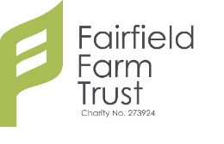
Holiday Workshop Booking Form
By completing this application form you agree to your personal data being kept on file until your 25th Birthday or the ceasing of your EHCP, whichever comes first.
Name of workshop:
Date of workshop:
Student name:
Student DoB:
Parent/Carer Name:
Student Disabilities:
Support Needs: | To note: any young person requiring 1:1 support to attend the workshop should provide their own support.
Allergies/Dietary:
Health/Medical:
Address:
Email:
Telephone:
Emergency Nos:
I give consent for facilitators to administer prescribed medication and basic first aid if needed: Yes/No
I give consent for facilitators to take photos and/or video for publicity materials: Yes/No
Signed parent/carer:
Date:
We would ask that payment is made directly to the Fairfield Farm Trust bank account.
For bank account details contact Shirley Raw, on 01225 823028
or the Finance team at: Finance@ffc.ac.uk

Any other queries, please contact Shirley Raw, as above.

